

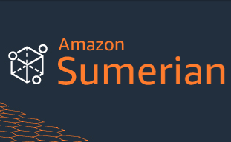  
Creating and running 3-D, augmented reality (AR) and virtual reality (VR) application by using AWS Services and giving the user an engaging experience.

**About Challenge**

The major challenges were the asset size issue, accent issue, superimposition of entities and using AWS Connect as a service for our use case

* Lex supports only US English Language
* Asset size cannot exceed 50MB
* Superimposing of the components.

**Details of the Workload** (Proposed)

**Application Stack:** .Python, HTML, CSS, Javascript,

**About AR/VR Chatbot**

A chatbot is a conversational Artificial Intelligence We have created a virtual environment which consists of an interactive chatbot for voice and text based interactions in a virtual environment. Our solution includes the real time conversations with the bot in a simulated environment. The user can also see the captioning of the responses which improves his / her experience. Our virtual environment also consists of a wall television which plays a video and adds to the aesthetics of the environment.

**AWS Services used**

* Sumerian
* Lex
* Lambda
* CloudFormation
* IAM
* Microsoft PowerShell Script

**Other Services used**

* Various objects that make up the scene are known as entities.
* The host of the scene is in sync with Amazon Lex – which is used for creating the bot.
* The bot books a car trip for the user after asking his / her preferences.
* Information required for such conversations is stored in a Lambda function.
* The function updates the configurations by adding it as a code hook.
* Responses of the bot are also visible to the user in the form of captions.
* Utterances and prompts that we have preconfigured are used for live time interactions.

**Proposed Solution**

* Seamless experience with live time responses.
* Conversational AI which interacts via written or spoken language.
* Using various assets to maintain the aesthetics of the simulated environment.

**Solution Outcome**

**Hosting Architecture – AWS Cloud**

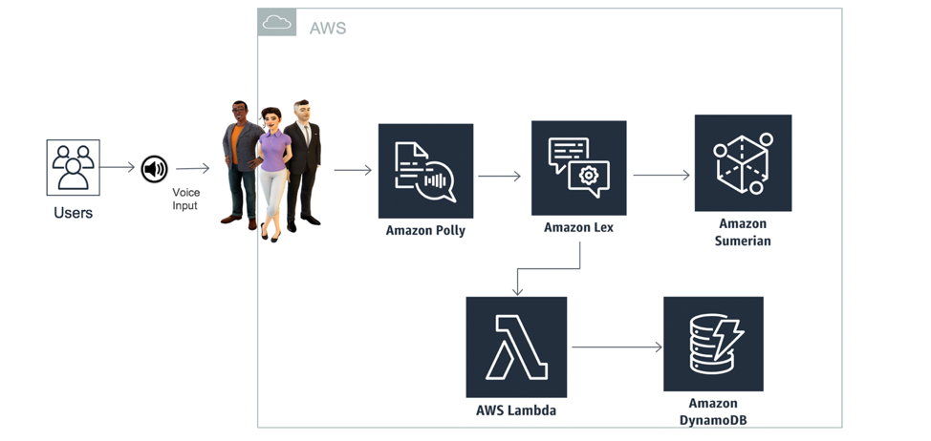

**State Machine to Trigger Bot**

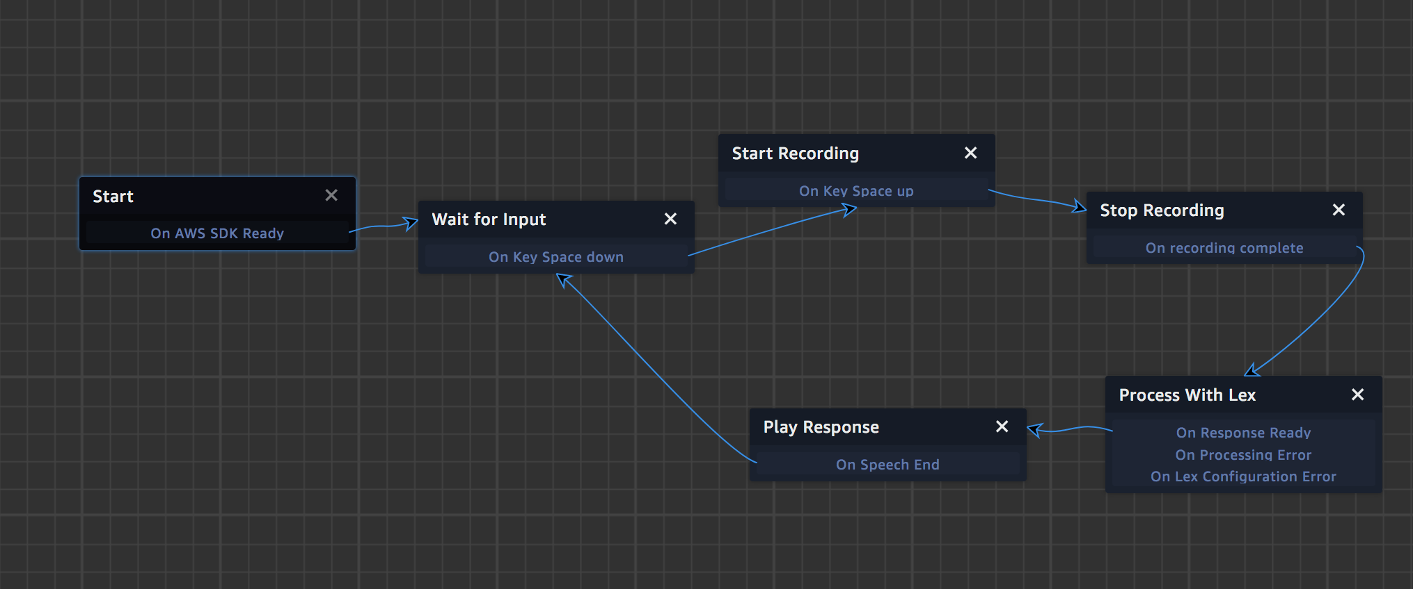

**How AWS services helped in building an engaging 3D front – end experience**

**AWS Sumerian helps in building interactive and engaging scenes which can be organized into a project and enable the users to tour the same.**

Amazon Lex lets us build a conversational interface and makes the technologies which power Amazon Alexa available to the developers and build chatbots. Amazon Polly turns the text into speech and assists in the questions and answers bot.

The lambda function, which is written in python, initializes and validates the input and acts as the back – end of the whole task.

About the Partner

MothersonSumi INfotech & Designs Ltd.

MothersonSumi INfotech & Designs Limited (MIND), a SEI CMMI Level 5 IT services company and the IT back bone of Motherson group. MIND is a trusted technology partner to over 200 clients globally. Our value proposition is in our strength in specific Industry segments and years of experience in the areas of intelligent warehousing, Supply chain enablement, software application development, smart ERP customization, infra managed services, cloud, IoT & Analytics. MIND is serving customers in 41+ countries with a strong team of 1500+ professionals.